CANSERRA COLLEGE OF SCIENCE AND TCHNOLOGY GRADUATES 2025
 | NAME/PICTURE | NAME | DEPARTMENT
1 | 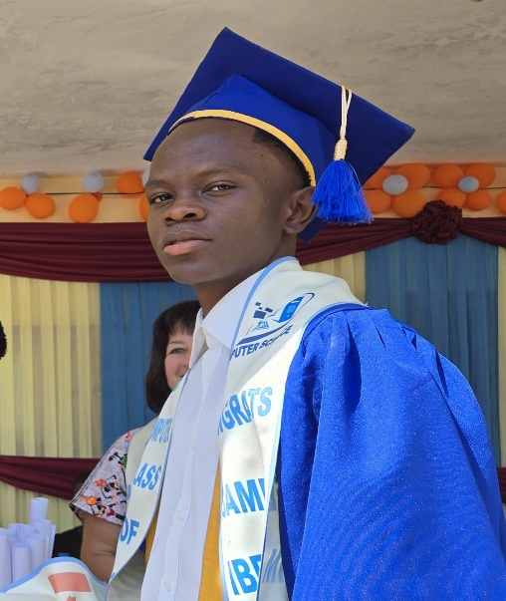 | SAMUEL IBRAHIM KAMARA | COMPUTER SCIENCE
2 | 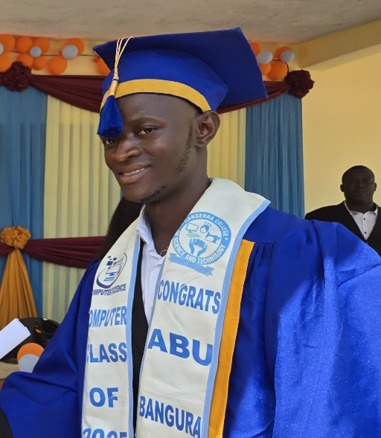 | ABU BANGURA | COMPUTER SCIENCE
3 | 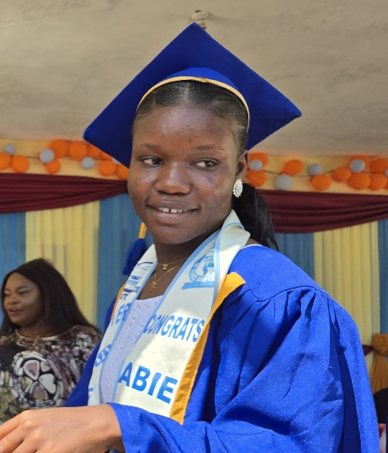 | ABIE SESAY | COMPUTER SCIENCE

CANSERRA COLLEGE OF SCIENCE AND TCHNOLOGY GRADUATES 2025
 | NAME/PICTURE | NAME | DEPARTMENT
4 | 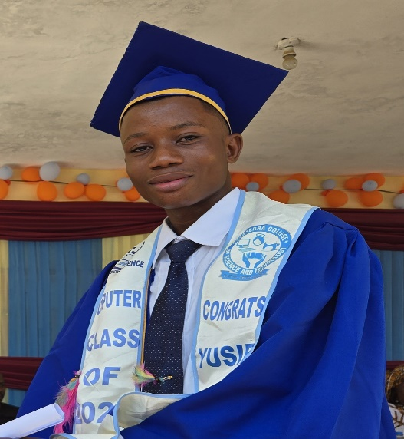 | YUSIF TURAY | COMPUTER SCIENCE
5 | 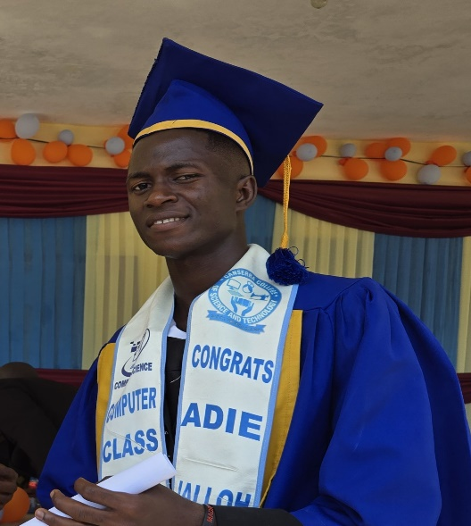 | ADIE JALLOH | COMPUTER SCIENCE
6 | 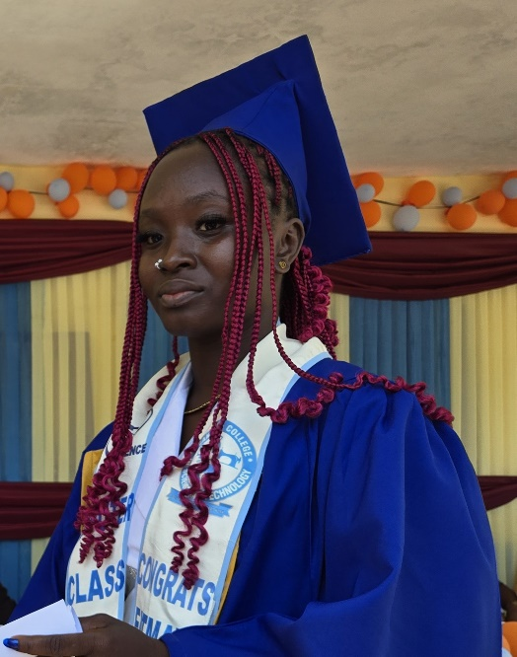 | FATMATA BANGURA | COMPUTER SCIENCE

CANSERRA COLLEGE OF SCIENCE AND TCHNOLOGY GRADUATES 2025
 | NAME/PICTURE | NAME | DEPARTMENT
7 | 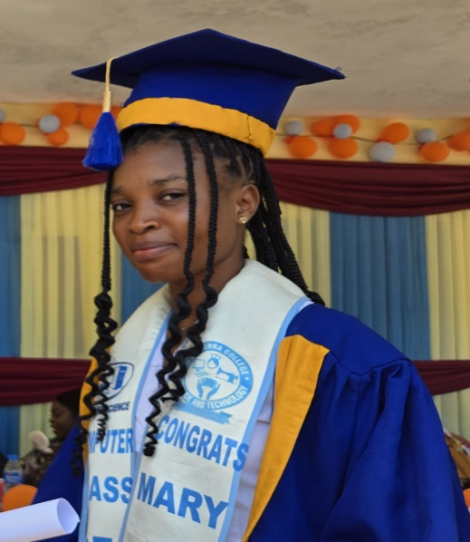 | MARY Y. THOLLEY | COMPUTER SCIENCE
8 | 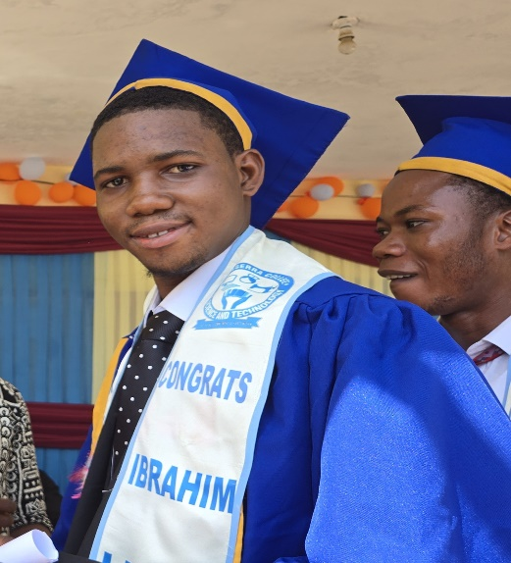 | IBRAHIM LEIGH | COMPUTER SCIENCE
9 |  | SAHR J. JOHNNEY | COMPUTER SCIENCE

CANSERRA COLLEGE OF SCIENCE AND TCHNOLOGY GRADUATES 2025
 | NAME/PICTURE | NAME | DEPARTMENT
10 | 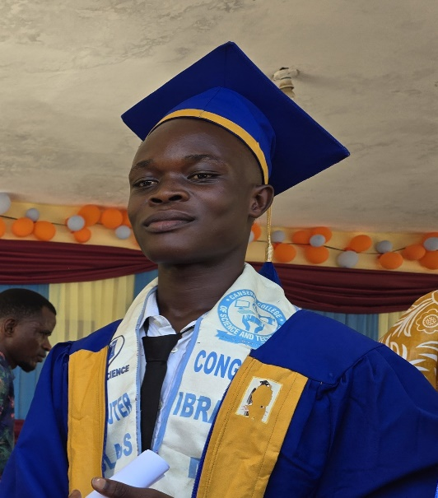 | IBRAHIM M. KANU | COMPUTER SCIENCE
11 | 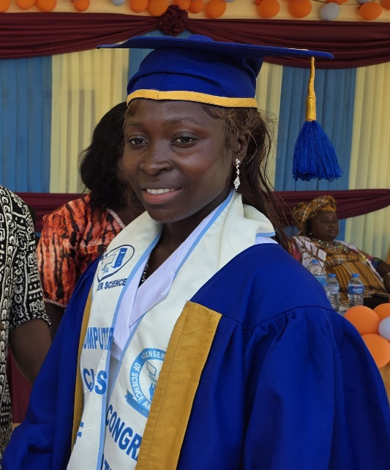 | PATRICIA KAMARA | COMPUTER SCIENCE
12 | 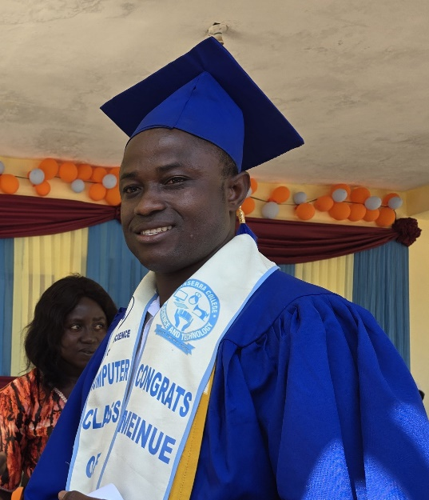 | MEINUE CAYTO | COMPUTER SCIENCE
CANSERRA COLLEGE OF SCIENCE AND TCHNOLOGY GRADUATES 2025
 | NAME/PICTURE | NAME | DEPARTMENT
13 | 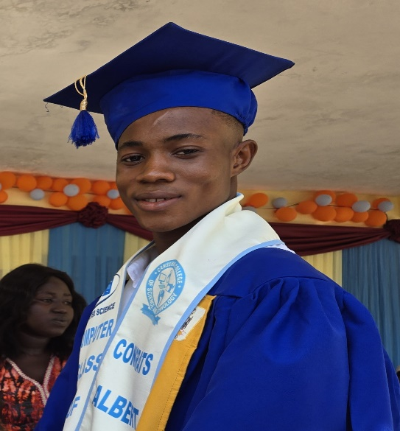 | ALBERT M. KAMARA | COMPUTER SCIENCE
14 | 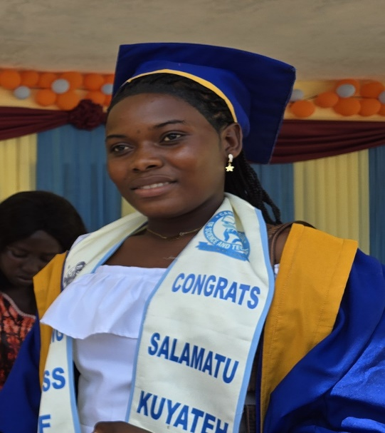 | SALAMATU KUTATEH | TAILORING
15 | 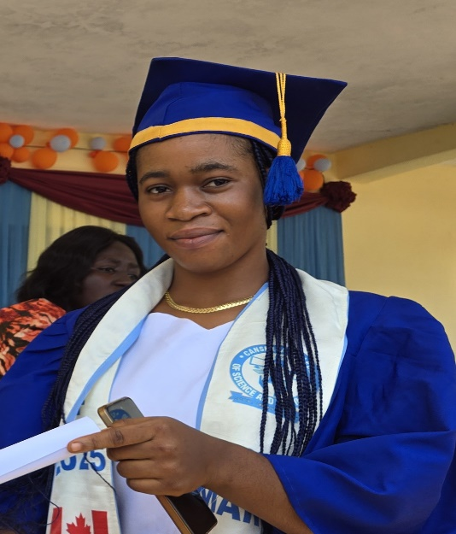 | MARY K. SESAY | TAILORING

CANSERRA COLLEGE OF SCIENCE AND TCHNOLOGY GRADUATES 2025
 | NAME/PICTURE | NAME | DEPARTMENT
16 | 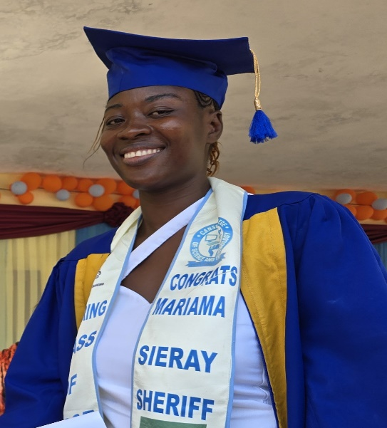 | MARIAMA SIERAY SHERIFF | TAILORING
17 | 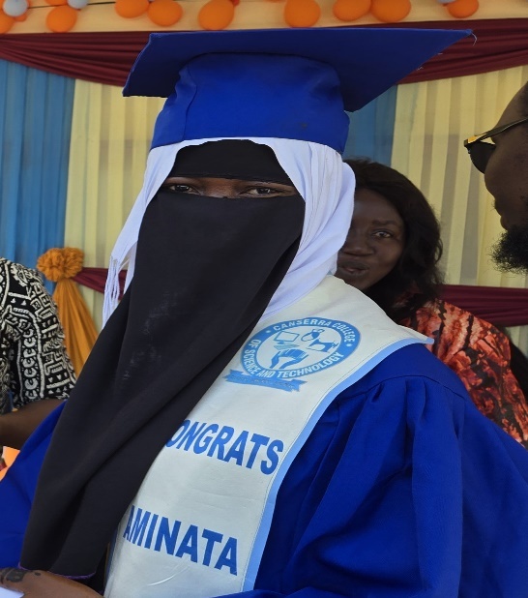 | AMINATA JALLOH | TAILORING
18 | 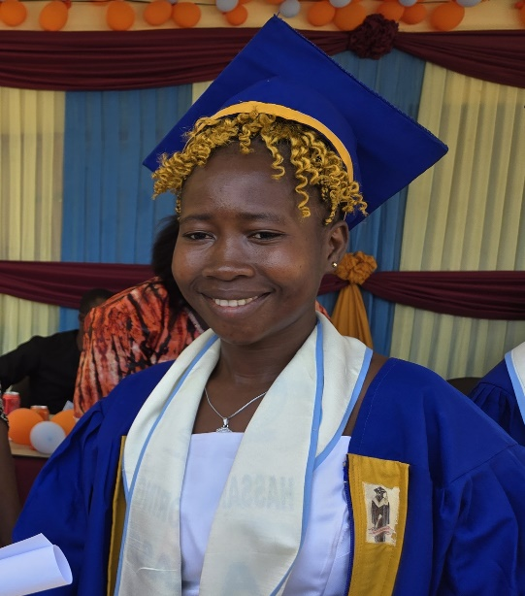
CANSERRA COLLEGE OF SCIENCE AND TCHNOLOGY GRADUATES 2025
 | NAME/PICTURE | NAME | DEPARTMENT
19 | 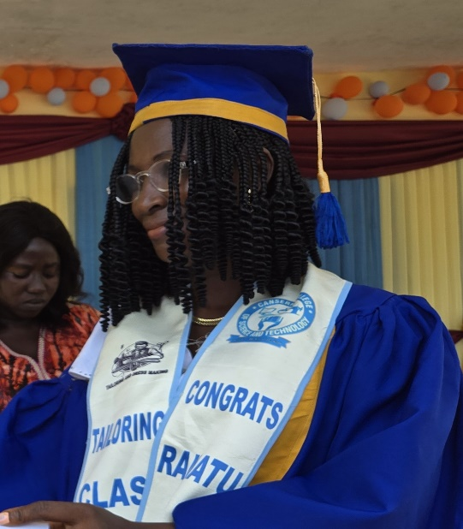 | RAMATU BANGURA | TAILORING
20 | 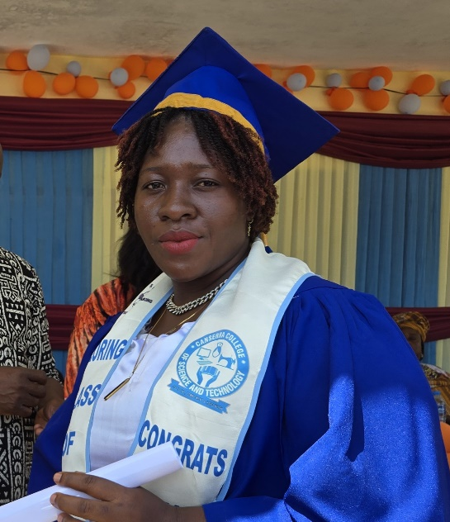 | AISHATU MUNU | TAILORING
21 | 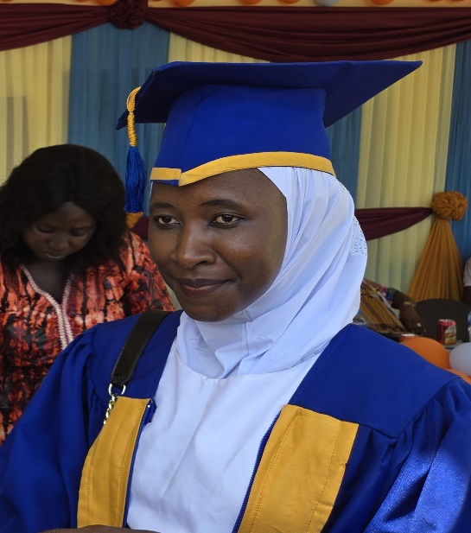 | ASANATU DUMBUYA | TAILORING
CANSERRA COLLEGE OF SCIENCE AND TCHNOLOGY GRADUATES 2025
 | NAME/PICTURE | NAME | DEPARTMENT
22 | 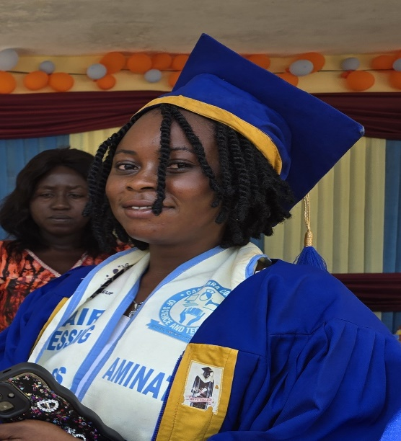 | AMINATA A. SESAY | HAIRDRESSING
23 | 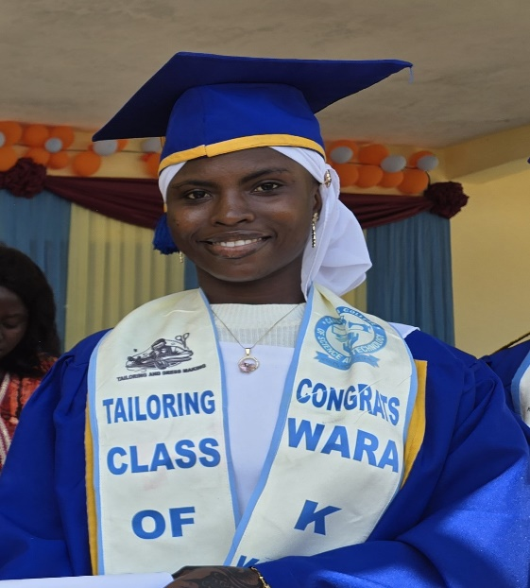 | WARA K. KAMARA | HAIRDRESSING
24 | 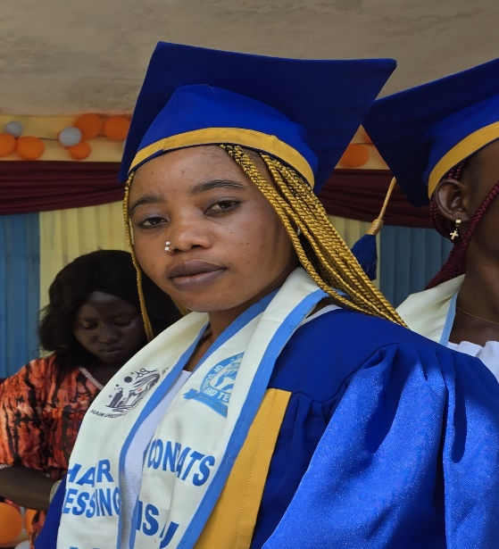 | ISATU KALOKOH | HAIRDRESSING
CANSERRA COLLEGE OF SCIENCE AND TCHNOLOGY GRADUATES 2025
 | NAME/PICTURE | NAME | DEPARTMENT
25 | 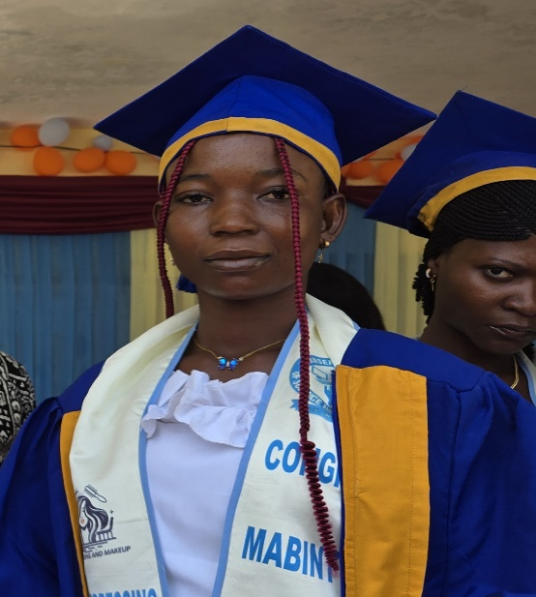 | MABINTY KOROMA | HAIRDRESSING
26 | 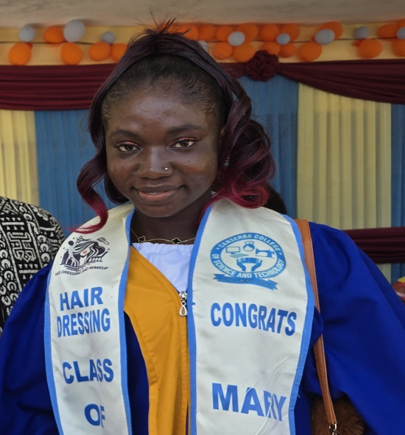 | MARY KAMARA | HAIRDRESSING
27 | 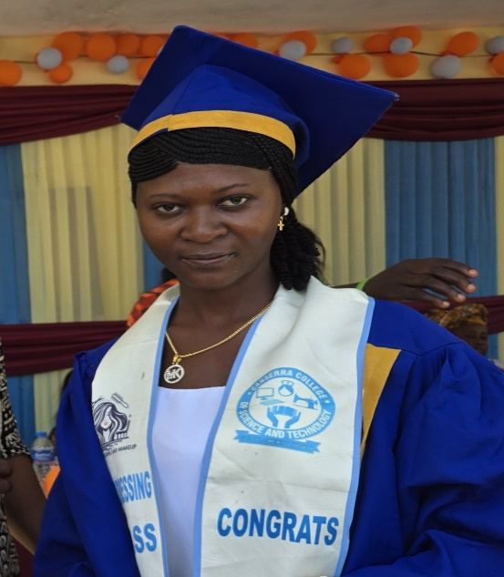 | KADIATU KAMARA | HAIRDRESSING
CANSERRA COLLEGE OF SCIENCE AND TCHNOLOGY GRADUATES 2025
 | NAME/PICTURE | NAME | DEPARTMENT
28 | 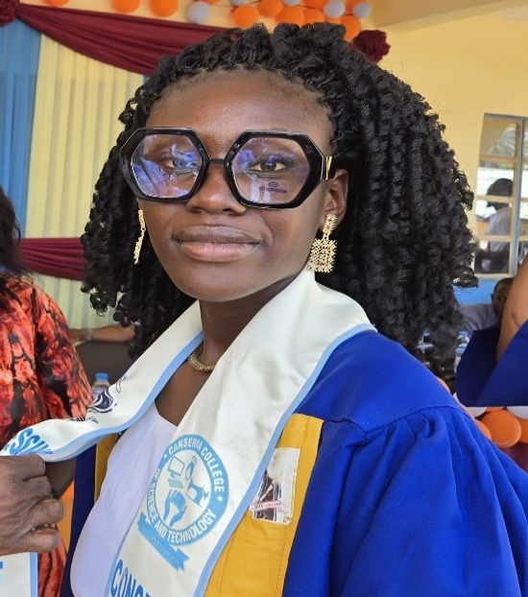 | AUGUSTA SHERIFF | HAIRDRESSING
29 | 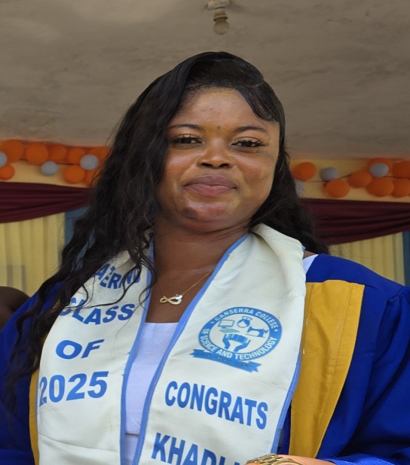 | KHADIJA KAMARA | CATERING
30 | 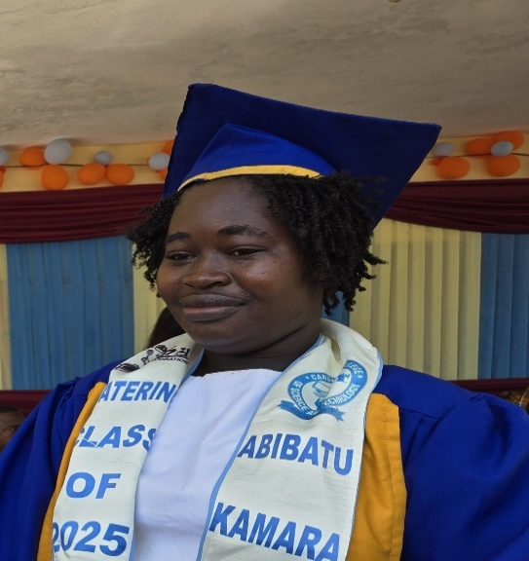 | ABIBATU KAMARA HILL | CATERING

CANSERRA COLLEGE OF SCIENCE AND TCHNOLOGY GRADUATES 2025
 | PHOTO/PICTURE | NAME | DEPARTMENT
31 | 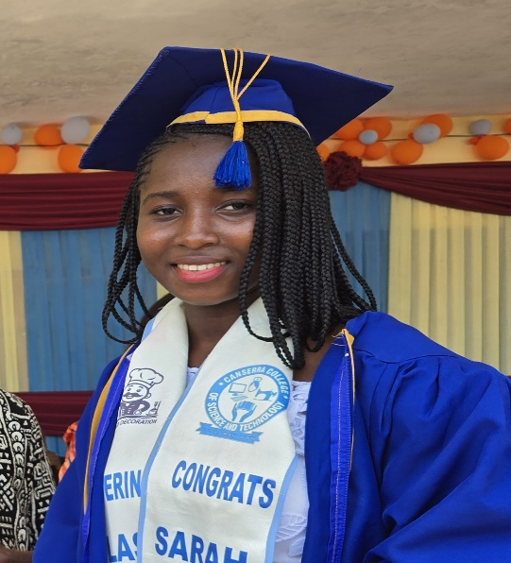 | SARAH KANU | CATERING
32 | 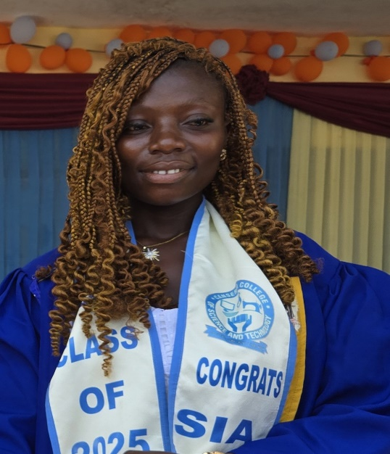 | SIA KAMANDA | CATERING
33 | 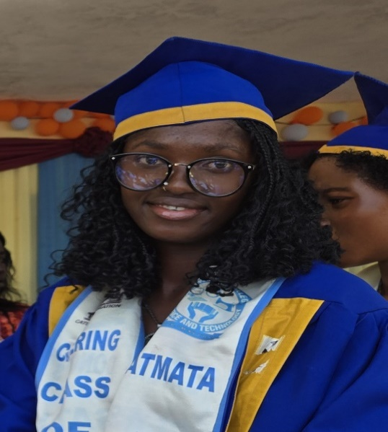 | FATMATA SESAY | CATERING

CANSERRA COLLEGE OF SCIENCE AND TCHNOLOGY GRADUATES 2025
 | NAME/PICTURE | NAME | DEPARTMENT
34 | 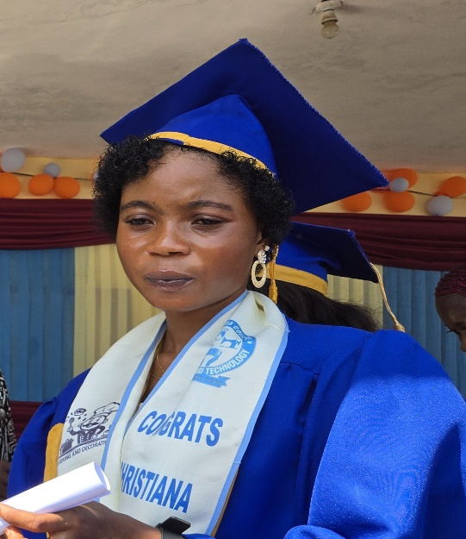 | CHRISTIANA Y. KAMARA | CATERING
35 | 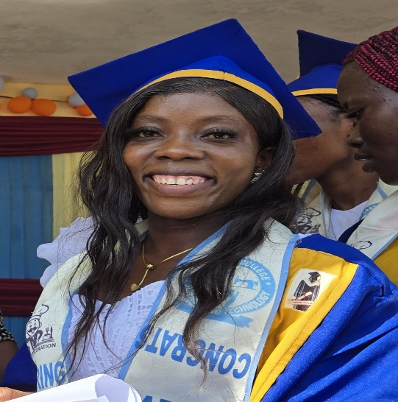 | MARTHA BANGURA | CATERING
36 | 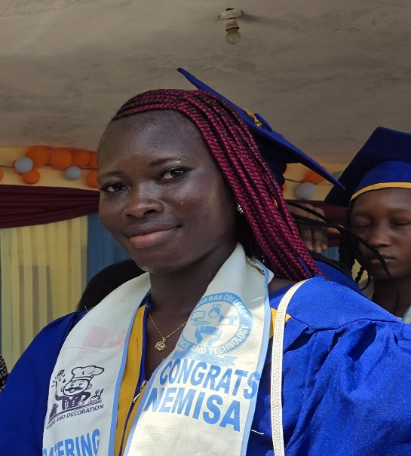 | NEMISA JABBIE | CATERING

CANSERRA COLLEGE OF SCIENCE AND TCHNOLOGY GRADUATES 2025
 | NAME/PICTURE | NAME | DEPARTMENT
37 | 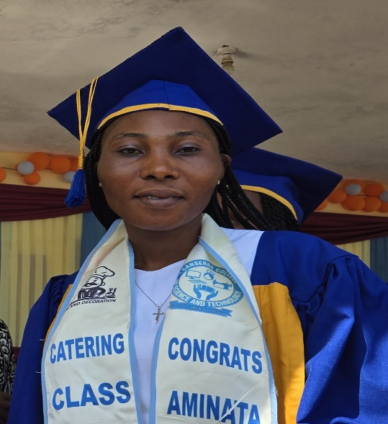 | AMINATA KOROMA | CATERING
38 | 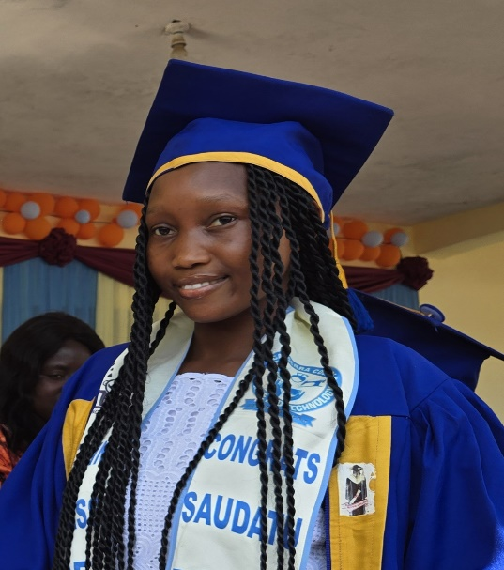 | SAUDATU BAIDOS SESAY | CATERING
39 | 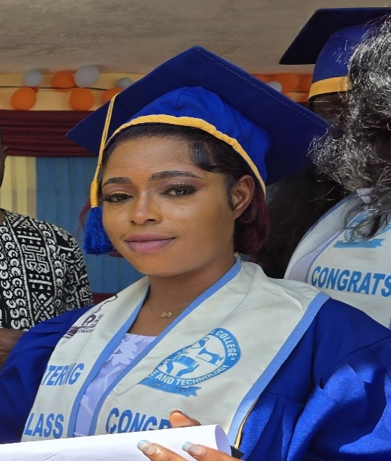 | KADIATU KAMARA | CATERING

CANSERRA COLLEGE OF SCIENCE AND TCHNOLOGY GRADUATES 2025
 | NAME/PICTURE | NAME | DEPARTMENT
40 | 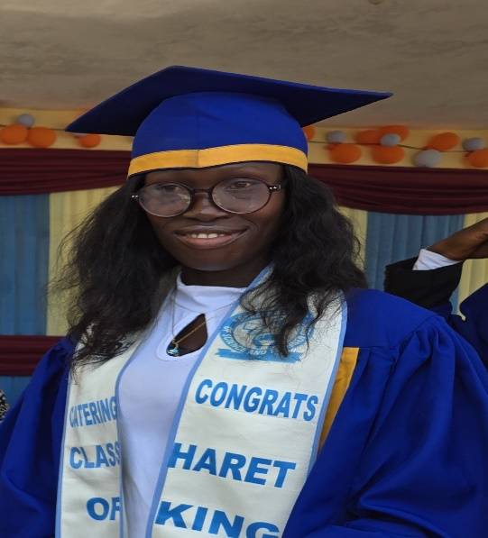 | HARITTE KING | CATERING
41 | 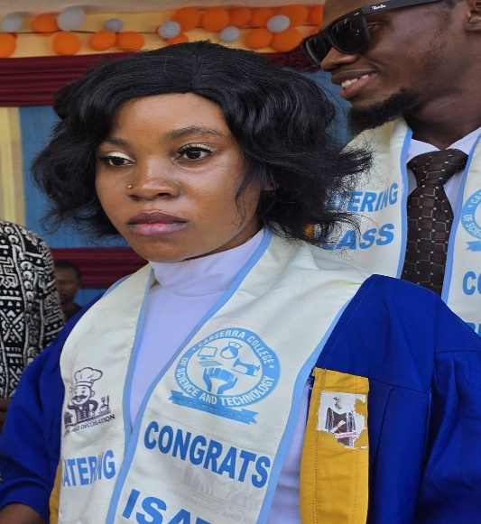 | ISATU BOCKARIE | CATERING
42 | 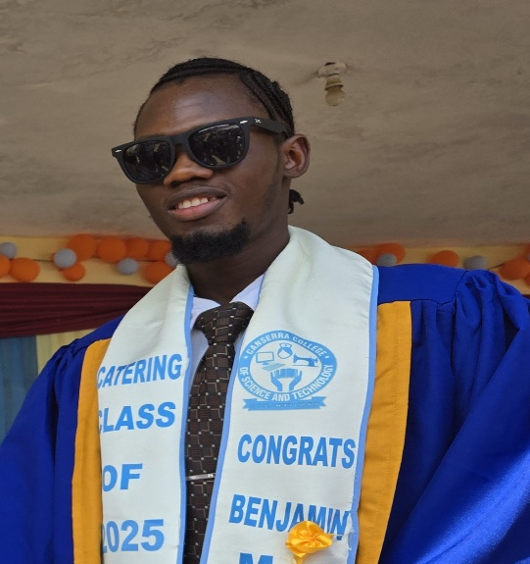 | BENJAMIN M. KAMARA | CATERING

CANSERRA COLLEGE OF SCIENCE AND TCHNOLOGY GRADUATES 2025
 | NAME/PICTURE | NAME | DEPARTMENT
43 | 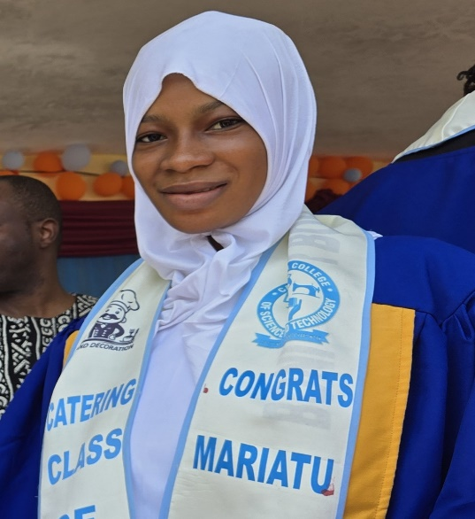 | MARIATU S. BANGURA | CATERING
44 | 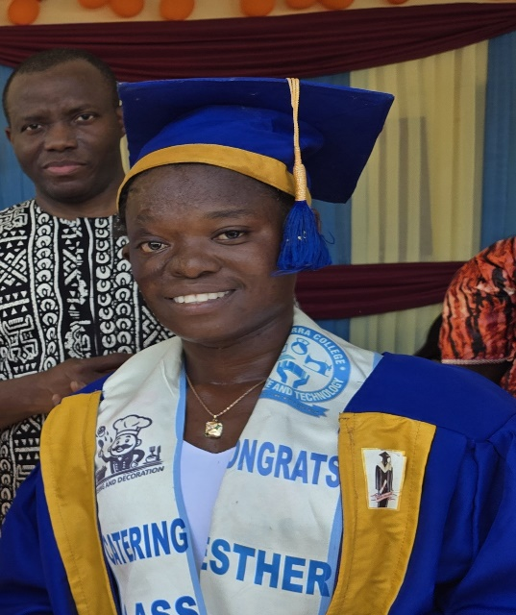 | ESTHER PASCAL | CATERING
45 | 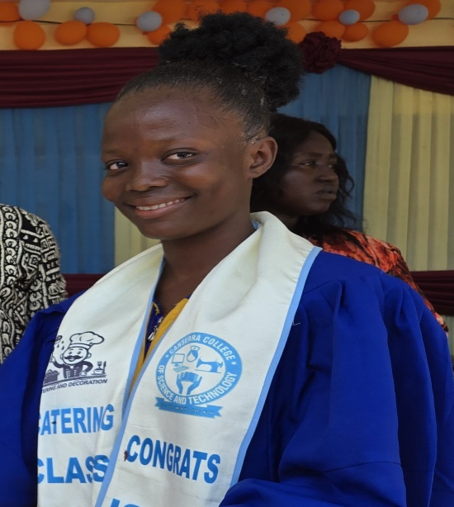 | ISATU KOROMA | CATERING
CANSERRA COLLEGE OF SCIENCE AND TCHNOLOGY GRADUATES 2025
 | NAME/PICTURE | NAME | DEPARTMENT
46 | 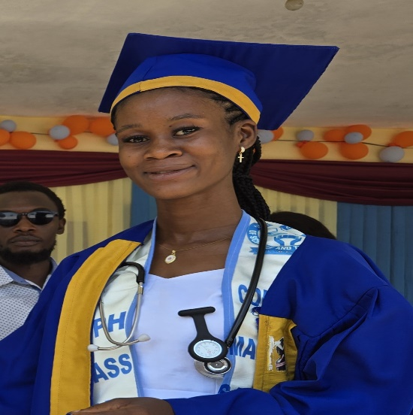 | MARGRET SANDY | REPRODUCTIVE HEALTH
47 | 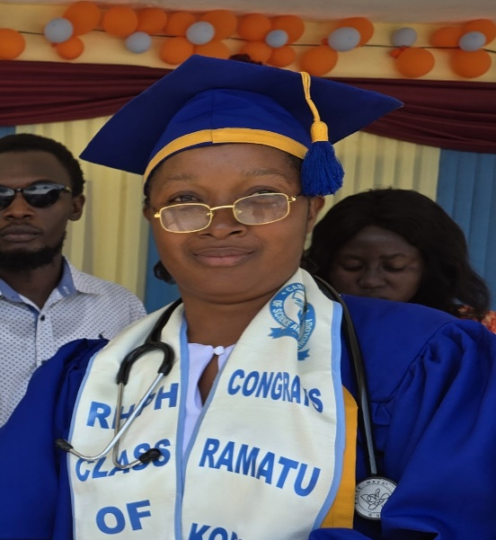 | RAMATU KOROMA | REPRODUCTIVE HEALTH
48 | 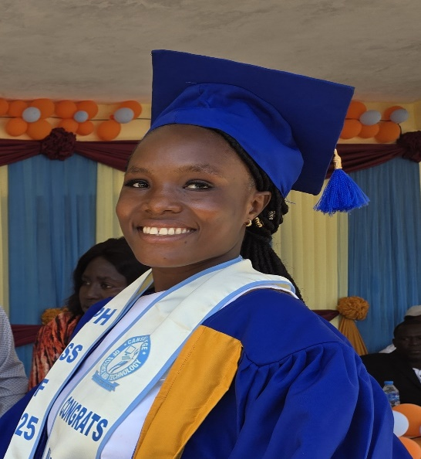 | MARIAMA CONTEH | REPRODUCTIVE HEALTH

CANSERRA COLLEGE OF SCIENCE AND TCHNOLOGY GRADUATES 2025
 | NAME/PICTURE | NAME | DEPARTMENT
49 | 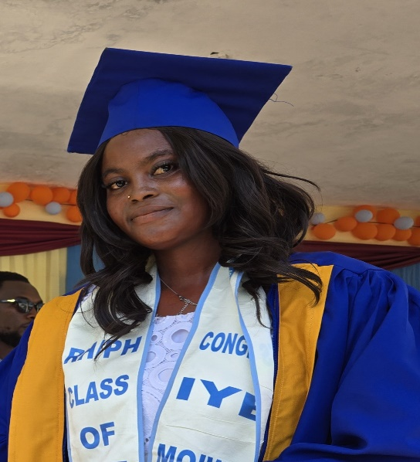 | IYE MOIWA | REPRODUCTIVE HEALTH
50 | 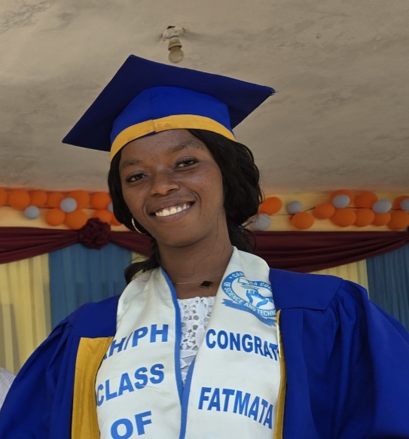 | FATMATA KARGBO | REPRODUCTIVE HEALTH
51 | 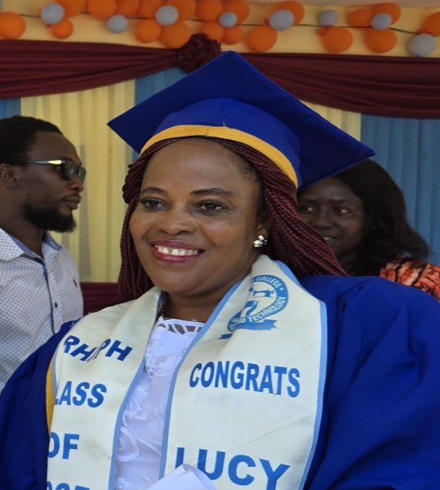 | LUCY KARGBO | REPRODUCTIVE HEALTH

CANSERRA COLLEGE OF SCIENCE AND TCHNOLOGY GRADUATES 2025
 | NAME/PICTURE | NAME | DEPARTMENT
52 | 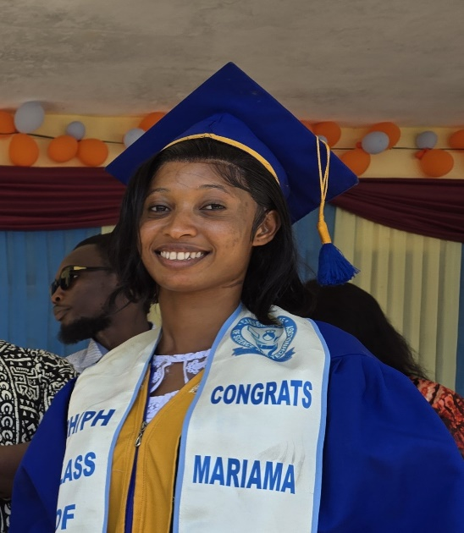 | MARIAMA CAULKER | REPRODUCTIVE HEALTH
53 | 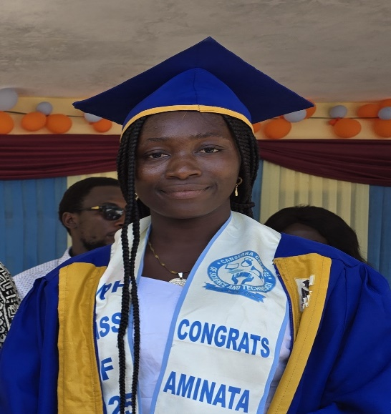 | AMINATA SESAY | REPRODUCTIVE HEALTH
54 | 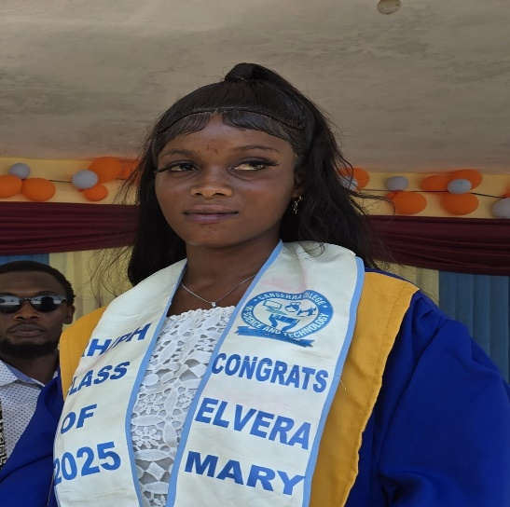 | ELVERA MARY WILLIAMS | REPRODUCTIVE HEALTH

CANSERRA COLLEGE OF SCIENCE AND TCHNOLOGY GRADUATES 2025
 | NAME/PICTURE | NAME | DEPARTMENT
55 | 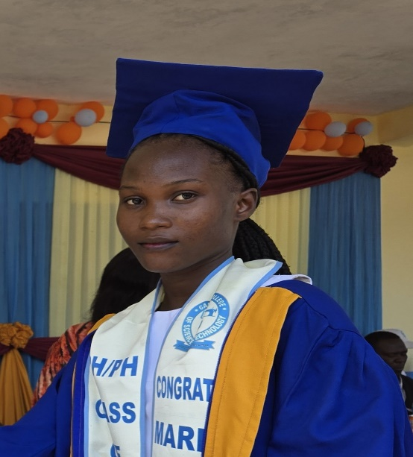 | JOSEPHINE KELLIE | REPRODUCTIVE HEALTH
56 | 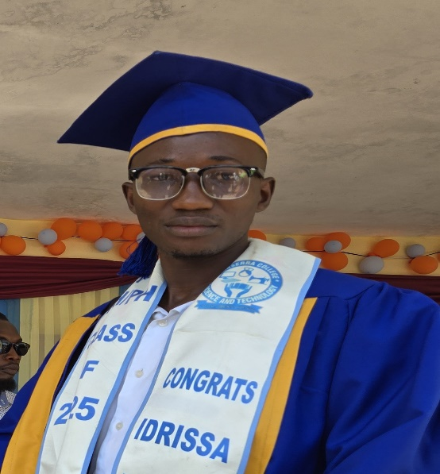 | IDRISSA FOFANAH | REPRODUCTIVE HEALTH
57 | 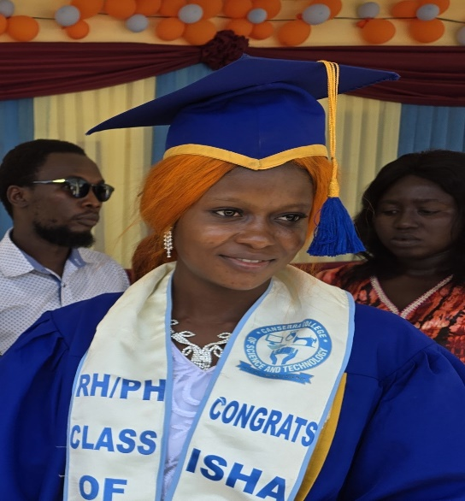 | ISHA KARGBO | REPRODUCTIVE HEALTH

CANSERRA COLLEGE OF SCIENCE AND TCHNOLOGY GRADUATES 2025
 | NAME/PICTURE | NAME | DEPARTMENT
58 | 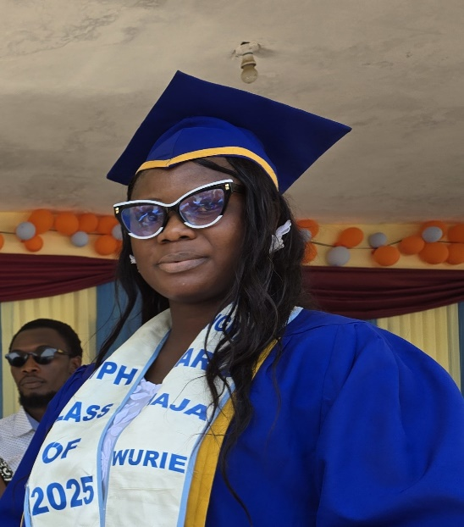 | HAJA WURIE | PUBLIC HEALTH
59 | 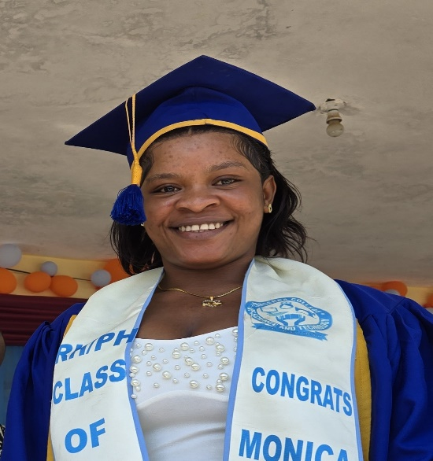 | MARY KOINEH | REPRODUCTIVE HEALTH
60 | 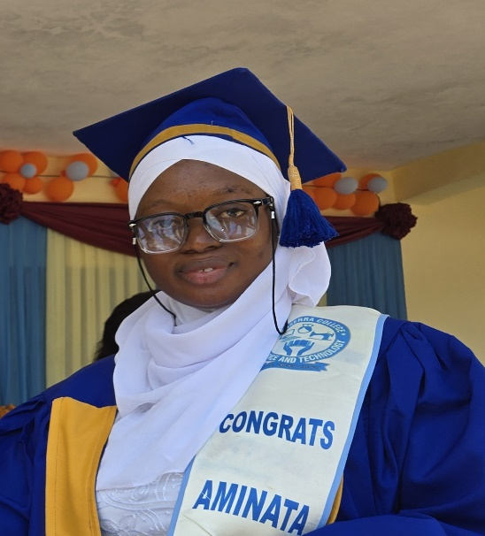 | AMINATA JAWARA | REPRODUCTIVE HEALTH

CANSERRA COLLEGE OF SCIENCE AND TCHNOLOGY GRADUATES 2025
 | NAME/PICTURE | NAME | DEPARTMENT
61 | 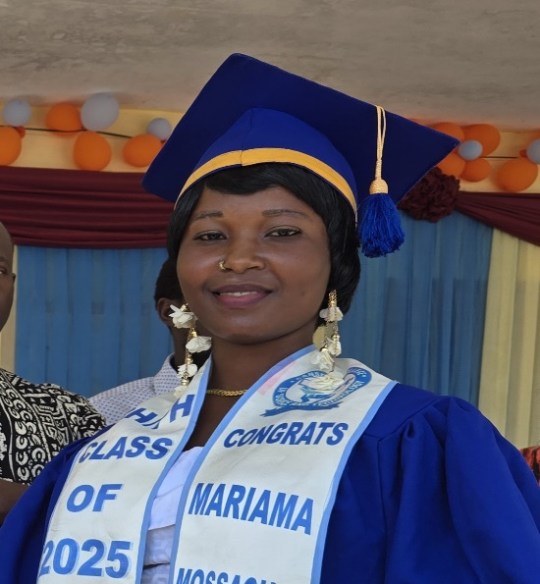 | MARIAMA MASSAQUOI | REPRODUCTIVE HEALTH
62 |  | UMU KAMARA | REPRODUCTIVE HEALTH
63 | 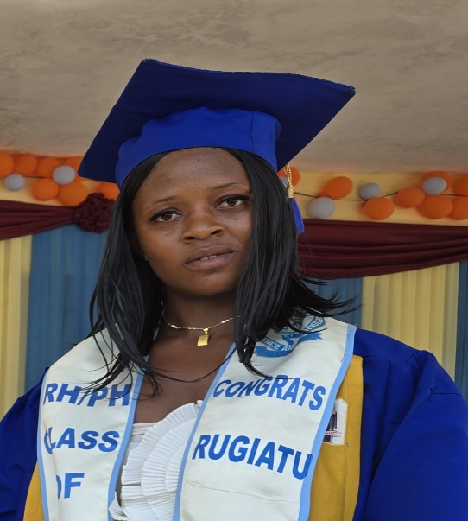 | RUGIATU TURAY | REPRODUCTIVE HEALTH

CANSERRA COLLEGE OF SCIENCE AND TCHNOLOGY GRADUATES 2025
 | NAME/PICTURE | NAME | DEPARTMENT
64 | 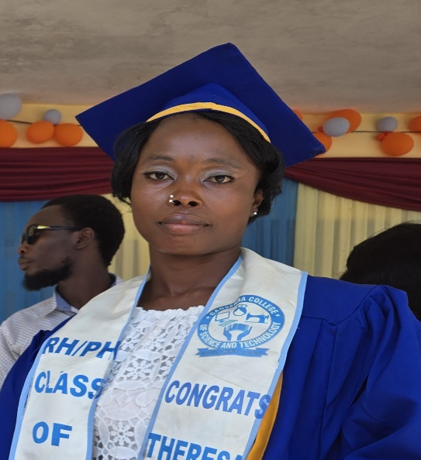 | THERESA CONTEH | REPRODUCTIVE HEALTH
65 | 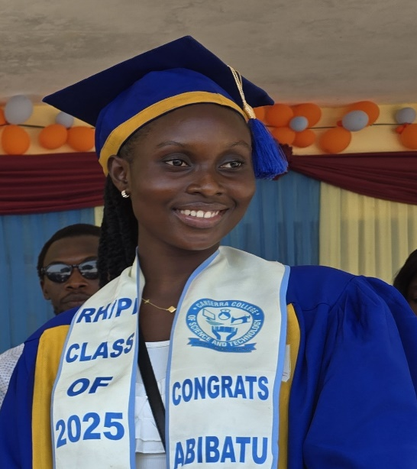 | ABIBATU PRINCESS ALIE SESAY | PUBLIC HEALTH
66 | 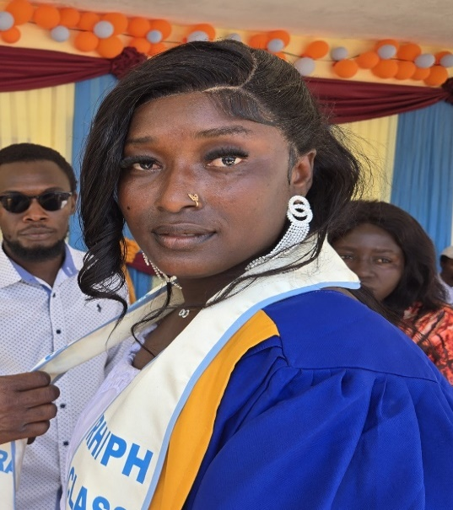 | POSSEH TURAY | REPRODUCTIVE HEALTH

CANSERRA COLLEGE OF SCIENCE AND TCHNOLOGY GRADUATES 2025
 | NAME/PICTURE | NAME | DEPARTMENT
67 | 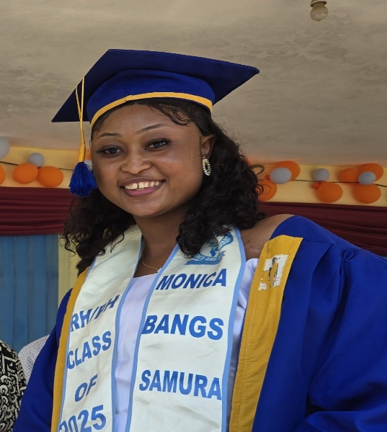 | MONICA BANGS SAMURA | REPRODUCTIVE HEALTH
68 | 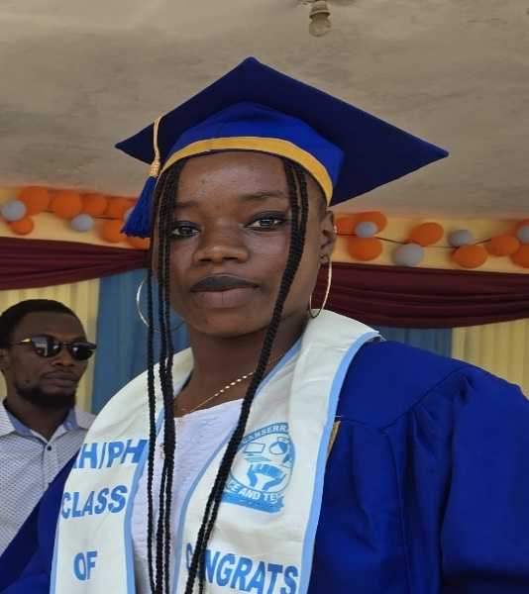 | MARY KOINEH | REPRODUCTIVE HEALTH
69 | 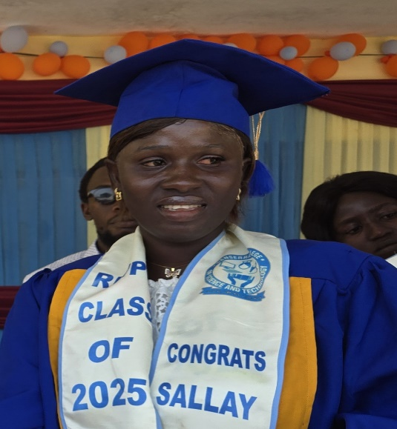 | SALLAY THERESA KOROMA | REPRODUCTIVE HEALTH

CANSERRA COLLEGE OF SCIENCE AND TCHNOLOGY GRADUATES 2025
 | NAME/PICTURE | NAME | DEPARTMENT
70 | 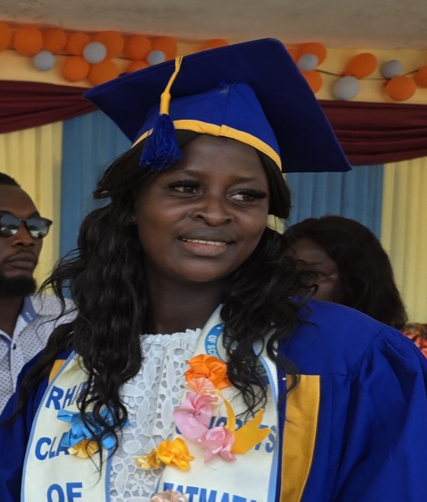 | FATMATA BANGURA | REPRODUCTIVE HEALTH
71 | 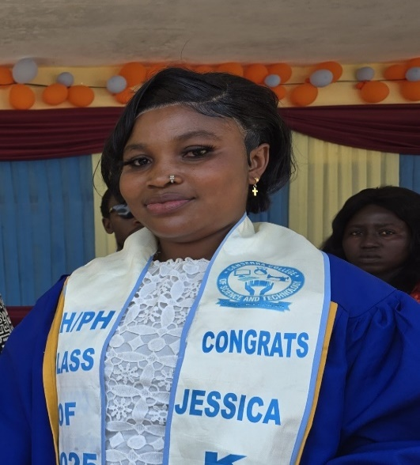 | JESSICA K. KAMARA | REPRODUCTIVE HEALTH
72 | 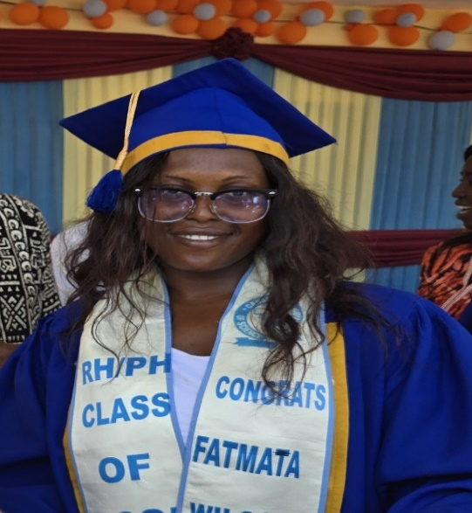 | FATMATA W. KAMARA | REPRODUCTIVE HEALTH

CANSERRA COLLEGE OF SCIENCE AND TCHNOLOGY GRADUATES 2025
 | NAME/PICTURE | NAME | DEPARTMENT
73 | 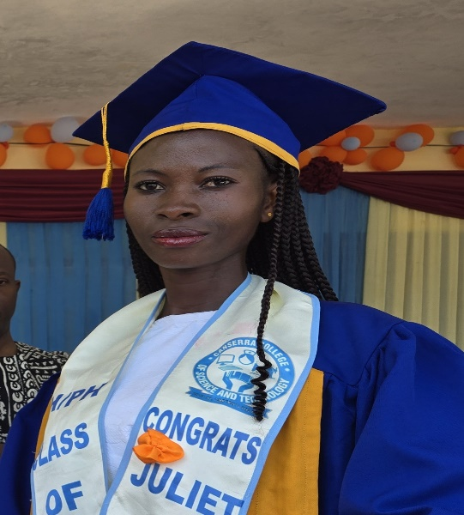 | JULIET M. WILL | REPRODUCTIVE HEALTH
74 | 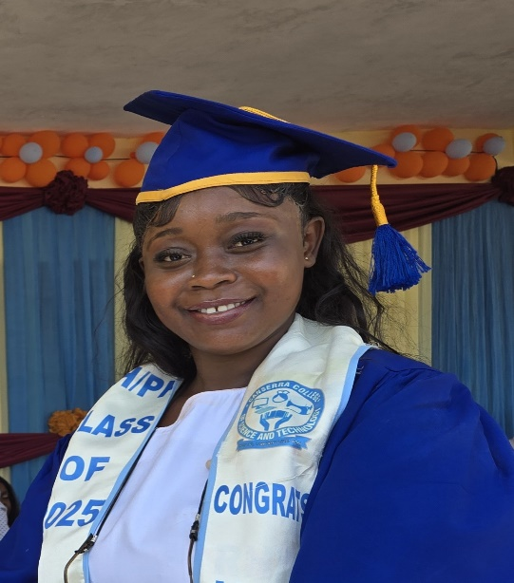 | JARIA JALLOH | REPRODUCTIVE HEALTH

